

Semester One Examination, 2024

Question/Answer booklet

MATHEMATICS METHODS
UNIT 3

Section Two:

Calculator-assumed

Your Name:
Your Teacher’s Name:

Time allowed for this section
Reading time before commencing work: ten minutes
Working time: one hundred minutes

Materials required/recommended for this section
To be provided by the supervisor
This Question/Answer booklet
Formula sheet (retained from Section One)

To be provided by the candidate
Standard items: pens (blue/black preferred), pencils (including coloured), sharpener, correction fluid/tape, eraser, ruler, highlighters

Special items: drawing instruments, templates, notes on two unfolded sheets of A4 paper, and up to three calculators approved for use in this examination

Important note to candidates
No other items may be taken into the examination room. It is your responsibility to ensure that you do not have any unauthorised material. If you have any unauthorised material with you, hand it to the supervisor before reading any further.

Question | Marks | Max | Question | Marks | Max
6 |  | 7 | 12 |  | 12
7 |  | 7 | 13 |  | 14
8 |  | 8 | 14 |  | 8
9 |  | 8
10 |  | 15
11 |  | 11

Structure of this paper

Section | Number of questions available | Number of questions to be answered | Working time (minutes) | Marks available | Percentage of examination
Section One:  Calculator-free | 5 | 5 | 50 | 46 | 33.8
Section Two:  Calculator-assumed | 9 | 9 | 100 | 90 | 66.2
 |  |  |  | Total | 100

Instructions to candidates

- The rules for the conduct of the Western Australian Certificate of Education ATAR course examinations are detailed in the Year 12 Information Handbook 2019. Sitting this examination implies that you agree to abide by these rules.

- Write your answers in this Question/Answer booklet.

- You must be careful to confine your answers to the specific questions asked and to follow any instructions that are specific to a particular question.

- Additional pages for the use of planning your answer to a question or continuing your answer to a question have been provided at the end of this Question/Answer booklet. If you use the space to continue an answer, indicate in the original answer space where the answer is continued, i.e. give the page number.

- Show all your working clearly. Your working should be in sufficient detail to allow your answers to be checked readily and for marks to be awarded for reasoning. Incorrect answers given without supporting reasoning cannot be allocated any marks. For any question or part question worth more than two marks, valid working or justification is required to receive full marks. If you repeat any question, ensure that you cancel the answer you do not wish to have marked.

- It is recommended that you do not use pencil, except in diagrams.

- The Formula sheet is not to be handed in with your Question/Answer booklet.

Section Two: Calculator-assumed (90 Marks)

This section has nine questions. Answer all questions. Write your answers in the spaces provided.

Spare pages are included at the end of this booklet. They can be used for planning your responses and/or as additional space if required to continue an answer.
● Planning: If you use the spare pages for planning, indicate this clearly at the top of the page.
● Continuing an answer: If you need to use the space to continue an answer, indicate in the original answer space where the answer is continued, i.e. give the page number. Fill in the number of the question that you are continuing to answer at the top of the page.

Working time: 100 minutes.

Question 6 (7 marks)
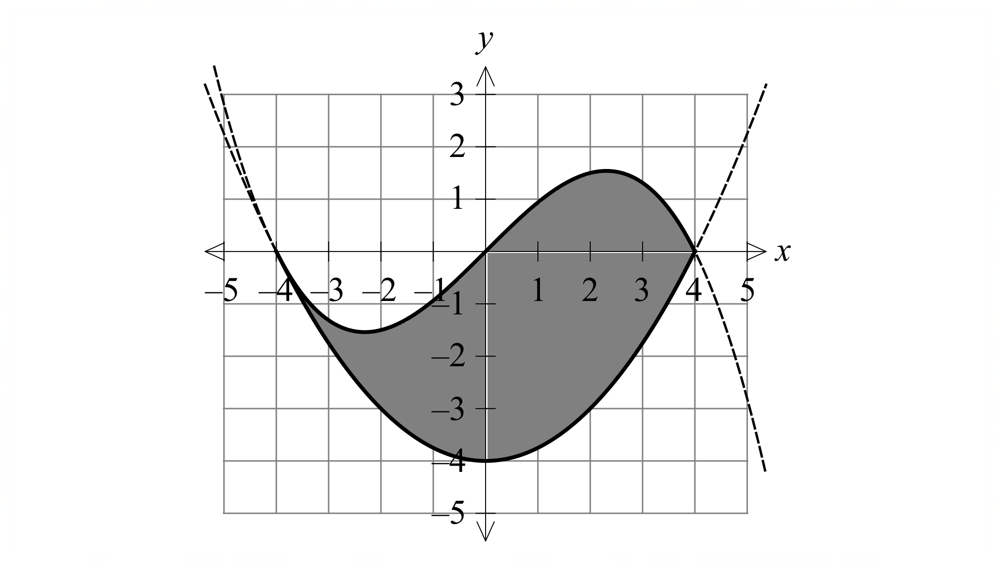
The diagram on the right shows a company logo shaded in grey.

The logo is bounded by two polynomials:

$$f\left(x\right)=\frac{1}{4}x^{2}-4$$
$$g\left(x\right)=k(16x-x^{3})$$

(a) Given that $f^{'}\left(-4\right)=g'(-4)$, determine the constant $k$. (2 marks)

Solution
$$f^{'}\left(x\right)=\frac{1}{2}x⇒f^{'}\left(-4\right)=-2$$
$$g^{'}\left(x\right)=16k-3kx^{2}⇒g^{'}\left(-4\right)=-32k$$
$$-2=-32k$$
$$∴k=\frac{1}{16}$$
Specific behaviours
- Differentiates $f(x)$ and determines gradient at $x=-4$.
- Determines value of $k$.

(b) Justify that $g(x)$ has only one point of inflection at $(0, 0)$. (2 marks)

Solution
$$g^{''}\left(x\right)=-\frac{3}{8}x=0$$
$$There is only one solution, and hence$$
$$only one point of inflection.$$
Specific behaviours
- Determines second derivative.
- Explains why there is only one point of inflection at $(0, 0)$.

A three-dimensional version of the logo is to be produced in acrylic for placement on the outside of a building. Each unit on the axes represents $1$ m.

(c) If the logo needs to be $30$ cm thick, determine the volume of acrylic needed to produce the logo. (3 marks)
Solution
$$A=\int_{-4}^{4}{\left(\frac{16x-x^{3}}{16}-\left(\frac{1}{4}x^{2}-4\right)\right)dx}$$
$$A=\frac{64}{3}m^{2}$$
$$V=\frac{64}{3}×0.3=6.4 m^{3}$$
Specific behaviours
- Writes an integral to determine the area between the two curves.
- Determines area between two curves.
- Determines volume with units

Question 7 (7 marks)
A tank initially contains $46$ litres of oil and $t$ hours later the rate of change of volume $V$ of oil in the tank is given by
$$\frac{dV}{dt}=-3e^{-0.06t}.$$

(a) At what rate is the volume of oil changing after $4.5$ hours? (1 mark)
Solution
$$V^{'}\left(4.5\right)=-3e^{-0.27}=-2.29 \text{L/h}$$

Specific behaviours
ü correct rate

(b) Determine an expression for $V$ as a function of time $t$. (2 marks)
Solution
$$V=\int{-3e^{-0.06t}}dt=50e^{-0.06t}+c$$
$$\left(0, 46\right)⇒c=-4, V=50e^{-0.06t}-4$$

Specific behaviours
correct antiderivative of rate
ü correct function

(c) What volume of oil is in the tank after $6$ hours? (1 mark)
Solution
$$V\left(6\right)=50e^{-0.36}-4=30.9 \text{L}$$

Specific behaviours
ü correct number of litres (no need for units)

(d) The mathematical model for the rate of change is only valid until there is no oil left in the tank. At what time does this occur? (1 mark)
Solution
$$50e^{-0.06t}-4=0⇒t=42.1 \text{h}$$

Specific behaviours
ü correct time(no need for units)

(e) Determine the rate at which oil is draining from the tank at the instant that it holds $6$ litres.
(2 marks)
Solution
$$50e^{-0.06t}-4=6⇒t=26.824 \text{or} e^{-0.06t}=0.2$$
$$V^{'}\left(26.824\right)=-0.6 \text{or }\frac{dV}{dt}=-3\left(0.2\right)=-0.6$$

Oil is draining at a rate of $0.6$ litres per hour.

Specific behaviours
ü indicates time or value of $e^{-0.06t}$
ü correct draining rate (no need for units)

Question 8 (8 marks)
A farmer plants saplings to replace trees felled for timber. The saplings grow independently of each other, and the farmer expects that $9\%$ of those planted will be lost to disease, insects, and other causes.

(a) The farmer plants $20$ saplings in a small field. For this plantation, determine

(i) the probability that $4$ saplings will be lost. (2 marks)
Solution
$$X\sim B\left(20, 0.09\right), P\left(X=4\right)=0.0703$$

Specific behaviours
indicates binomial distribution, with parameters
ü correct probability

(ii) the probability that more than one sapling will be lost. (1 mark)
Solution
$$P\left(X>1\right)=P\left(X≥2\right)=0.5484$$

Specific behaviours
ü correct probability

(iii) the most likely number of saplings that will be lost. (1 mark)
Solution
Largest value of $P(X=x)$ is when $x=1$ and so the most likely number to lose is $1$.

Specific behaviours
correct integer

(b) In a much larger field, $45$ rows of $36$ saplings are planted.

(i) Show that the probability that in one randomly chosen row no more than $3$ saplings will be lost is $0.5912$. (2 marks)
Solution
$$Y\sim B\left(36, 0.09\right), P\left(Y≤3\right)=0.591208=0.5912$$

Specific behaviours
states binomial distribution, with parameters
ü correct probability statement

(ii) Determine the probability that less than half of the rows will lose no more than
$3$ saplings. (2 marks)
Solution
$$W\sim B\left(45, 0.5912\right), P\left(W<\frac{45}{2}\right)=P\left(W≤22\right)=0.1073$$

Specific behaviours
indicates binomial distribution, with parameters
ü correct probability

Question 9 (8 marks)
The temperature $T$ $℃$ of an oven, $t$ minutes after being turned on, changes according to the function
$$\frac{dT}{dt}=at-\sin\left(\frac{t}{3}\right)+\frac{3}{4}\cos\left(\frac{t}{4}\right), 0≤t≤40,$$

where $a$ is a constant.

(i) When $a=0.3$, is the rate of change of temperature of the oven greater when $t=1$ or $t=3$? Justify your answer. (2 marks)
Solution
When $t=1, T^{'}=0.70$ and when $t=3, T^{'}=0.61$.

The rate of change is greatest after $1$ minute.

Specific behaviours
correctly evaluates one rate
ü states correct time, with correct justification

(ii) When $a=0.3$ and the initial temperature of the oven is $17℃$, determine its temperature $30$ minutes after being turned on. (3 marks)

Solution
$$ΔT=\int_{0}^{30}{\left(0.3t-\sin\left(\frac{t}{3}\right)+\frac{3}{4}\cos\left(\frac{t}{4}\right)\right) }dt \\ =132.3$$

Hence the oven temperature will be $17+132.3=149.3℃$.

Specific behaviours
ü correct integral for change in temperature
ü correct change in temperature
ü correct oven temperature(no need for units)

(iii) An oven had an initial temperature of $22℃$. Determine the value of the constant $a$ for this oven given that $15$ minutes after being turned on its temperature was $80℃$. (3 marks)
Solution
$$ΔT=\int_{0}^{15}{\left(at-\sin\left(\frac{t}{3}\right)+\frac{3}{4}\cos\left(\frac{t}{4}\right)\right) }dt \\ ∴80-22=112.5a-3.8637 \\ a=0.55$$

Specific behaviours
correct integral for change in temperature
ü uses integral to form equation for $a$
ü correct value of $a$

Question 10 (15 marks)

The velocity $v$ ms⁻¹ of a particle travelling along a straight line is shown on the graph below.

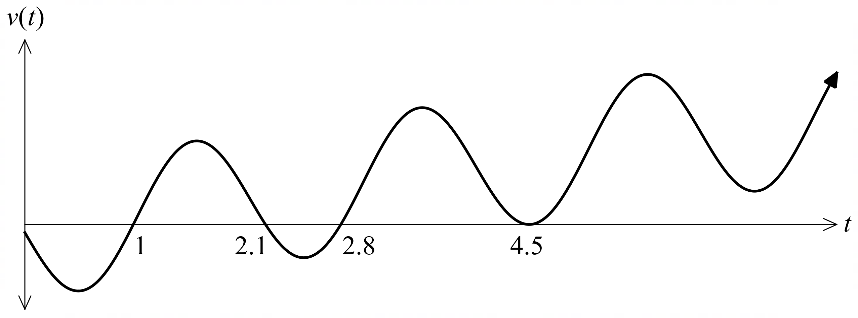

All the roots of $v(t)$ are shown on the graph above.

(a) How many times does the particle change direction? Justify your answer by referring to the above graph. (2 marks)

Solution
$$Three times.$$
$$The graph indicates that the velocity$$
$$changes sign at t=1, 2.1 and 2.8$$
Specific behaviours
- States three times.
- Justifies by referring to how velocity changes sign at the roots of the graph (excluding t = 4.5)

(b) What is the displacement of the particle as $t→∞$? Justify your answer by referring to the above graph. (2 marks)

Solution
$$As t→∞, v\left(t\right)>0 hence the particle is$$
$$moving away from the origin in$$
$$a positive direction.$$
Specific behaviours
- States it is moving away from the origin.
- States the direction of movement and justifies by referring to the velocity.

The same velocity graph is shown below along with the $t$-coordinates of the turning points, and the area of the four regions ($A_{1}$, $A_{2}$, $A_{3}$ and $A_{4}$) that are enclosed between the graph and the $t$-axis.

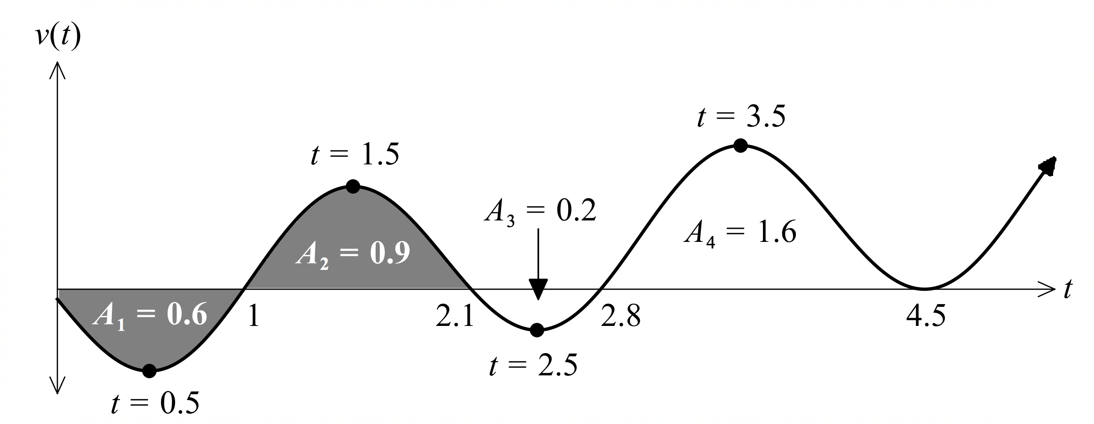

(c) Determine when the particle first has positive acceleration. (2 marks)

Solution
$$a\left(t\right) = v^{'}\left(t\right)$$
Therefore the first positive acceleration occurs when the gradient of the velocity graph is first positive.
$$0.5<t<1.5$$
or after $t=0.5$
Specific behaviours
- Recognises that positive acceleration is when the rate of change of velocity is positive.
- Correct interval.

(d) (i) Write down an integral expression for the distance travelled in the first 4.5 seconds.
(2 marks)

Solution
$$distance=\int_{0}^{4.5}{\left|v\left(t\right)\right|}dt$$
Specific behaviours
- Identifies distance as integral of speed (absolute value of velocity) or splits integral with correct signs.
- Writes correct integral(s) with boundaries.

(ii) Hence, determine the distance travelled in the first 4.5 seconds. (2 marks)

Solution
$$distance=0.6+0.9+0.2+1.6$$
$$=3.3 m$$
Specific behaviours
- Uses a calculation consistent with answer to part (d)(i).
- Determines distance travelled with correct units.

(e) Describe what the signed area of the shaded region in the figure represents. (2 marks)

Solution
$$The change in displacement of the$$
$$particle from t=0 to t=2.1 seconds.$$
Specific behaviours
- States area represents change in displacement.
- States correct time interval.

The particle starts at the origin.

(f) Determine how many times that the particle will pass through the origin for $t>0$, justifying your answer. (3 marks)

Solution
$$Particle returns once.$$
$$In the first second the particle travels 0.6 m to the left. The particle then travels 0.9 m to$$
$$the right. ∴it passes through the origin and after 2.1 seconds is 0.3 m to the right.$$
$$Between 2.1 and 2.8 seconds the particle travels to the left 0.2 m, and$$
$$after 2.8 continues to travel to the right.$$
Specific behaviours
- States particle will pass through the origin once with an attempted explanation.
- Uses the signed areas and part (e) to explain why the particle must have passed through the origin in between 1 and 2.1 seconds.
- Explains why the particle will never return to the origin after 2.1 seconds.

Question 11 (11 marks)
Consider 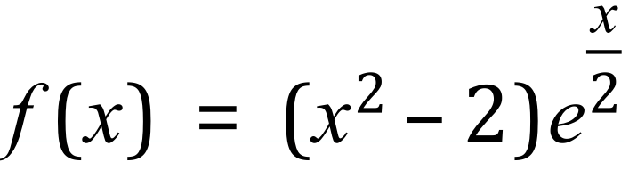
- Use calculus to determine all the stationary points of $f(x)$ and determine their nature. (5 marks)

Solution
$$f^{'}\left(x\right)= \frac{e^{\frac{x}{2}}\left(x^{2}+4x-2\right)}{2}$$
$$f^{'}\left(x\right)=0 ⟹x= \sqrt{6}-2, -\sqrt{6}-2=0.4495, -4.4495$$
$$f^{''}\left(x\right)= \frac{e^{\frac{x}{2}}\left(x^{2}+8x+6\right)}{4}$$

$$f^{''}\left(\sqrt{6}-2\right)=3.0067>0 ⟹Local Minima$$
$$f\left(\sqrt{6}-2\right)=-2.251$$

$$f^{''}\left(-\sqrt{6}-2\right)=-0.26477<0 ⟹Local Maxima$$
$$f( -\sqrt{6}-2)=1.9239$$

Specific behaviours
- Sets first derivative equal to 0.
- Obtains the two solutions
- Finds the second derivative
- Justifies the local maxima with value of second derivative and obtains y coordinate
- Justifies the local minima with value of second derivative and obtains y coordinate
Note: may use first derivative sign test with values either side.

- Determine the coordinates of any points of inflection. (2 marks)

Solution
$$f^{''}\left(x\right)= \frac{e^{\frac{x}{2}}\left(x^{2}+8x+6\right)}{4}=0$$
$$⟹x= \sqrt{10}-4, -\sqrt{10}-4=-7.1623, -0.8377$$

$$f( -\sqrt{10}-4)=1.3727$$
$$f\left(\sqrt{10}-4\right)=-0.8540$$

Specific behaviours
- Equates second derivative to zero..
- States coordinates of both points

- Hence sketch the graph of $f(x)$, clearly indicating the location of all stationary points and points of inflection. (4 marks)

Solution
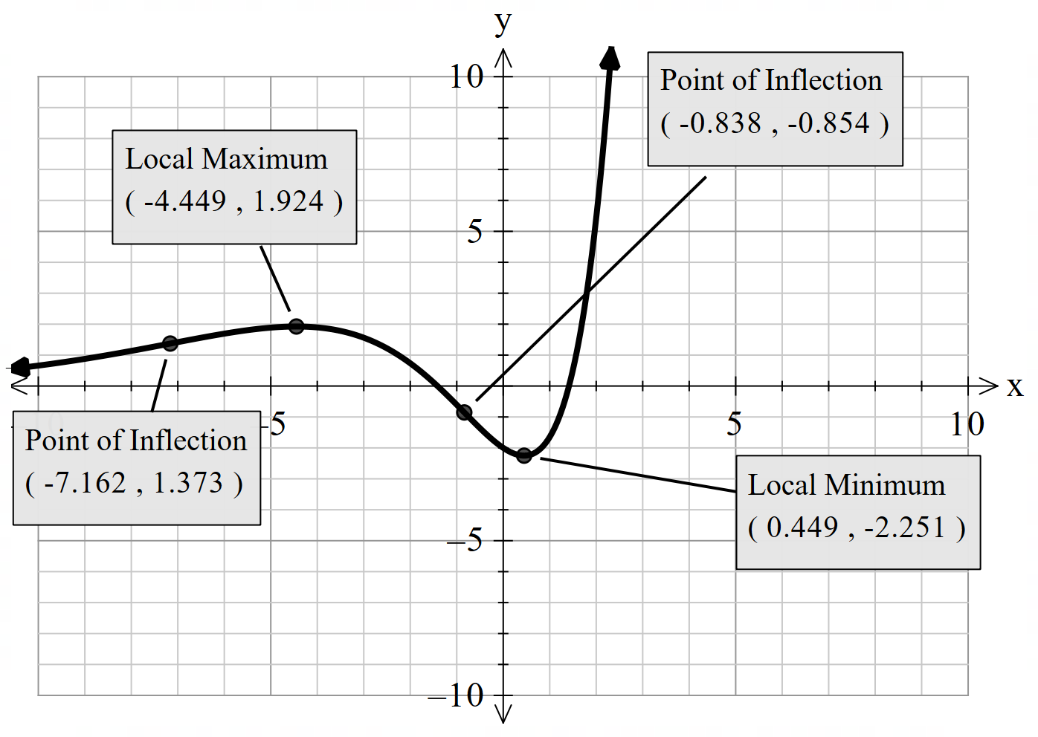
Specific behaviours
- Indicates local minima
- Indicates local maxima
- Indicates points of inflection
- Overall shape
-1 for not labelling the coordinates of the key points
-1 for not labelling the nature of the key points

Question 12 (12 marks)
A group of Year 12 students plan to run a “Triple Roll” game stall for their school’s Community Day event.
The game consists of three 8-sided dice, numbered 1 to 8, each placed in a cup. The cup is shaken, the dice rolled, and the number of sevens are recorded.
Let X be a random variable denoting the number of sevens rolled in a Triple Roll game.
- State the distribution of X. (2 marks)
Solution
$$X\sim Bin(3, \frac{1}{8})$$
Specific behaviours
- States that the distribution is binomial.
- States correct values for parameters $n$ and $p$.

An incomplete probability distribution for X is shown in the table below.
$$x$$ | $$0$$ | $$1$$ | $$2$$ | $$3$$
$$P(X=x)$$ | $$\frac{343}{512}=0.6699$$ | $$\frac{147}{512}=0.2871$$ | $$\frac{21}{512}=0.0410$$ | $$\frac{1}{512}=0.002$$

- Complete the table above, providing the missing probabilities. (2 marks)
Solution
$$See table above.$$
Specific behaviours
- Calculates one probability
- Calculates remaining two probabilities
Each player pays $2 to play Triple Roll game. If a player rolls one 7 they win $2, if they roll two 7s, they win $4 and if they roll three 7s they win $7.
- Determine the school’s expected profit/loss for each game of Triple Roll. (3 marks)
Solution
$$Let Y be a random variable denoting the profit from a game of Triple Roll.$$
$$The distribution for Y is shown in the table below.$$

$$y$$ | 2 | 0 | -$2$ | -4
$$P(Y=y)$$ | $$\frac{343}{512}=0.6699$$ | $$\frac{147}{512}=0.2871$$ | $$\frac{21}{512}=0.0410$$ | $$\frac{1}{512}=0.002$$

Hence the expected profit is $E\left(Y\right)=2×\frac{343}{512}+\left(-2× \frac{21}{512}\right)+\left(-4 ×\frac{1}{512}\right)=1.248$
The school’s expected profit from each game is $1.25.

Specific behaviours
- Correctly determines probability distribution for the profit per game.
- Writes correct expression for the expected profit.
- Calculates correct expected profit.
Note: max of 1 mark out of 3 if no working shown

- Determine the probability that a player will make a profit in a game of Triple Roll. (2 marks)
Solution
$$A player will money if 2 or more sevens are rolled.$$
$$P\left(X≥2\right)=P\left(X=2\right)+P\left(X=3\right)= 0.0410+0.002=0.0430$$
Specific behaviours
- Correct probability statement
- Calculates correct proabibility

Year 12 students want to increase the attraction of the game by providing the opportunity for larger winnings. They modify the rules of the game so that players only win money when two or more 7s are rolled and the winnings for rolling three 7s is five times as much as the winning for rolling of two 7s. Each game still costs $2 to play. Year 12 students estimated that they should be able to run 300 games and wants to make profit of $200 for the school.
- Determine the winnings Year 12 students should set for rolling three 7s with the modifications above. (3 marks)

Solution
$$Let Z be a random variable denoting the profit from the above game.$$
$$In order to make \$200 in 300 games, the expected profit per game must be$$
$$E\left(Z\right)=\frac{200}{300}=\frac{2}{3}=0.67$$
$$Let W denote the winnings for two 7s.$$
$$The distribution for Z is shown in the table below.$$

$$y$$ | 2 | 2 | 2-W | 2-5W
$$P(Y=y)$$ | $$\frac{343}{512}=0.6699$$ | $$\frac{147}{512}=0.2871$$ | $$\frac{21}{512}=0.0410$$ | $$\frac{1}{512}=0.002$$

Hence the expected profit per game is
$$E\left(Z\right)=2×\frac{343}{512}+2×\frac{147}{512}+(2-W)×\frac{21}{512}+(2-5W)×\frac{1}{512}$$

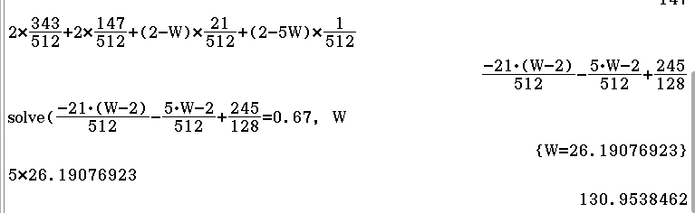
Hence the winnings for rolling three 7s should be set at $\$130.95.$
OR
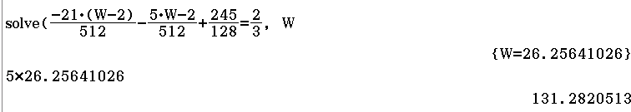
Specific behaviours
- Correctly calculates expected profit per game
- Obtains correct equation for expected profit in terms of unknown winnings
- Obtains correct winnings for three 7s

Question 13 (14 marks)
Calculus amusement park is planning to construct a zipline adventure above a scenic hill within its premises. The hill where the zipline will be installed is modelled by
$$h\left(x\right)=15x\left(π-\frac{x}{10}\right)+15\sin\left(x-\frac{π}{10}\right)$$
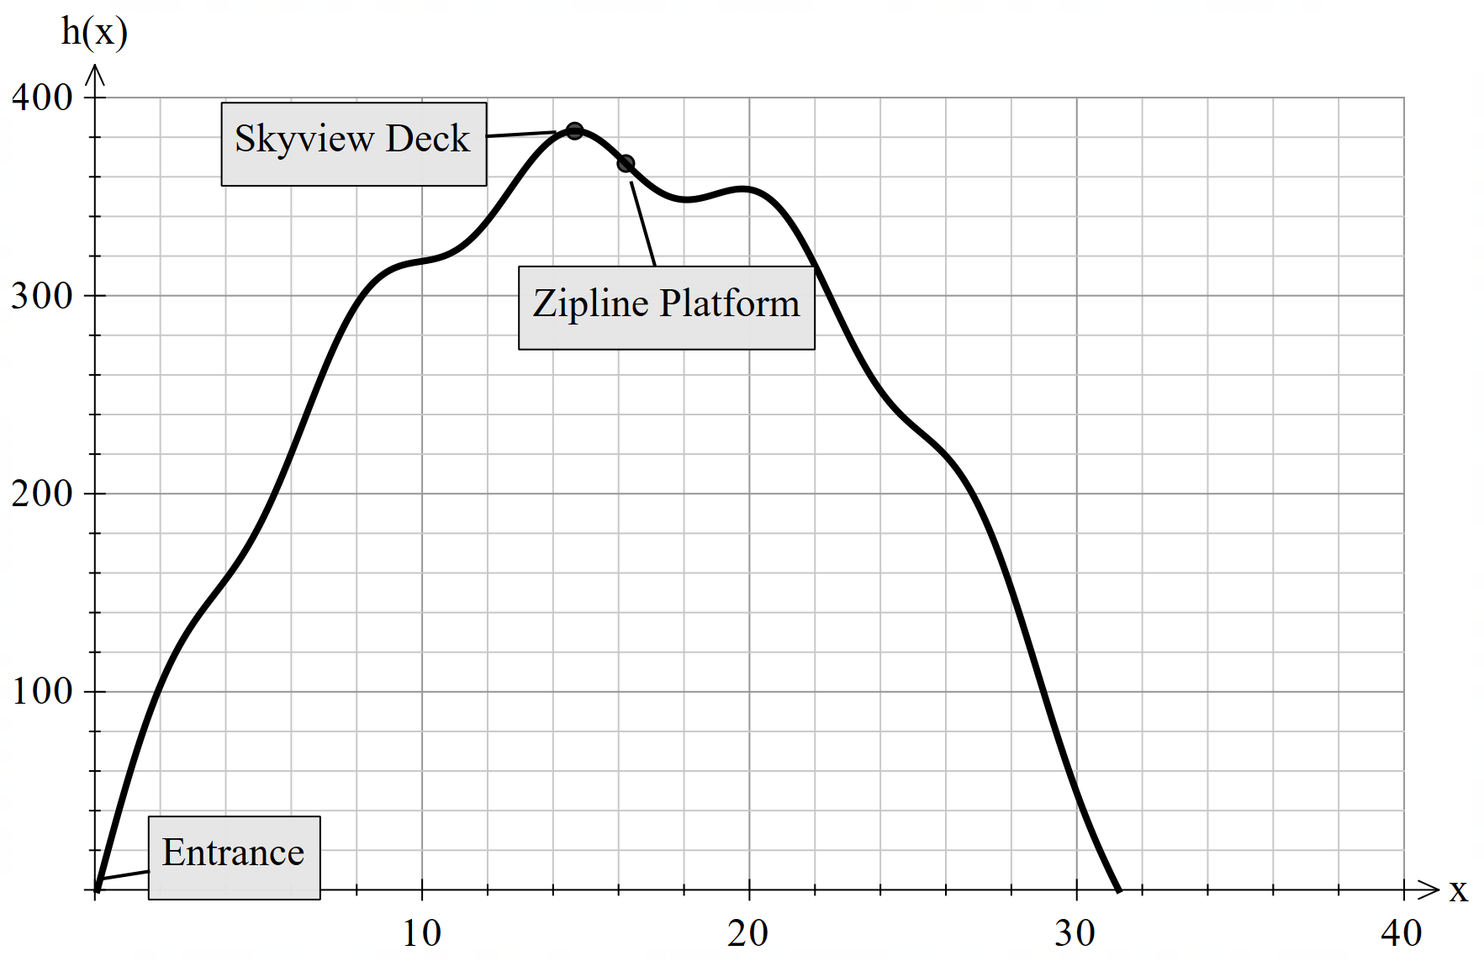where $h\left(x\right)$ is the height (in metres) of the hill and $x$ is the horizontal distance in metres.

- Determine $h^{'}(x)$. (2 marks)
Solution
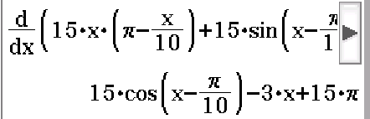
Specific behaviours
- Shows use of product rule.
- Differentiates $h(x)$.

- Visitors will need to take a cable car first to reach the Sky view Deck, which is the highest point of the hill. Determine, to the nearest centimetre, the value of $x$at which the height of the hill is maximum and state this maximum height. (4 marks)
Solution
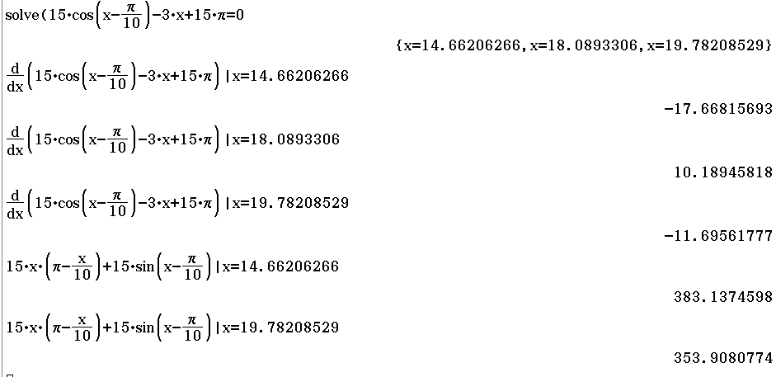

Maximum height is 383.14 metres at x = 14.66 metres
Specific behaviours
- Sets $h^{'}\left(x\right)=0,$and solves it to obtain three $x-values$.
- Evaluates the second derivative at all three points
- Determine $y coordinates$ at both points of maxima.
- States that maximum height with units

- Visitors will take the cable car from the entrance to reach the sky view deck. This entrance is located at the first steepest point of the hill. How high off the ground, to the nearest centimetre is it positioned? Consider the horizontal distance (3 marks)

Solution
The climb is steepest when the gradient is maximum.

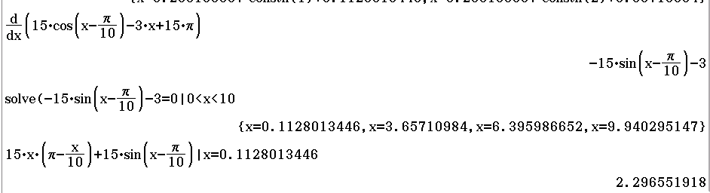

When $x=0.1128$, the entrance is 2.30 metres above the ground.
Specific behaviours
- Obtains the second derivative
- Equates $h^{''}\left(x\right)=0$ and determines at least first two positive values of $x$
- Identifies correct point in stated interval (first steepest point) rounded to nearest cm and determines the height of the entrance.
(Note: max of 1 mark out of 3 marks if no working)

The distance,  , travelled along the zipline is given by
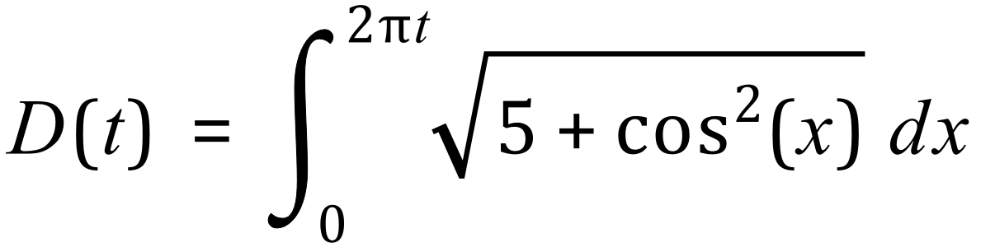
Where is measured in metres and 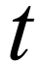 is measured in seconds.

- Determine the speed 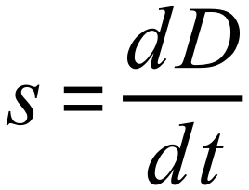 of the person on the zipline when 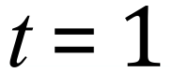 . (3 marks)

Solution
Applying fundamental theorem of calculus
$$\frac{dD}{dt}= 2π\sqrt{5+\cos^{2}(2πt)}$$
When $t=1$,
$$\frac{dD}{dt}\left(1\right)= 2π\sqrt{5+\cos^{2}\left(2π\right)}=15. 3905 m/s$$

Specific behaviours
- Applies fundamental theorem of calculus.
- Correctly applies chain rule
- Evaluates $\frac{dD}{dt}$ at $t=1.$

- Use the increments formula to estimate the distance travelled by the object between 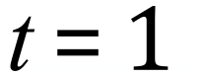 and 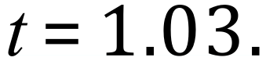 (2 marks)

Solution
The increment in $t$is $δt=1.03-1=0.03$
Hence
$δD≈\frac{dD}{dt}\left(1\right)×δt=15.3905×0.03$
$$=0.4617m$$
Specific behaviours
- Determines correct increment for t.
- Applies increments formula to obtain correct answer.

Question 14 (8 marks)
The probability distribution of the discrete random variable $X$ is $P\left(X=x\right)=\left\{\begin{matrix}\begin{matrix}a \\ \overline{x}\end{matrix} & x=2, 3 \\ \begin{matrix}b \\ \overline{2x}\end{matrix} & x=4, 5, 6 \\ 0 & \text{otherwise}\end{matrix}\right.$
where $a$ and $b$ are constants and $E\left(X\right)=4.3$.

(a) Determine $P(X=3)$. (4 marks)
Solution
Sum of probabilities:
$$\frac{a}{2}+\frac{a}{3}+\frac{b}{8}+\frac{b}{10}+\frac{b}{12}=1⇒\frac{5a}{6}+\frac{37b}{120}=1$$

Expected value
:
$$\frac{2a}{2}+\frac{3a}{3}+\frac{4b}{8}+\frac{5b}{10}+\frac{6b}{12}=4.3⇒2a+\frac{3b}{2}=4.3$$

Solving using CAS gives $a=\begin{matrix}11 \\ \overline{40}\end{matrix}=0.275$ and $b=2.5$.

$$P\left(X=3\right)=\begin{matrix}11 \\ \overline{40}\end{matrix}÷3=\frac{11}{120}=0.091\overline{6}$$

Specific behaviours
forms equation using sum of probabilities
ü forms equation using expected value
ü solves equations for variables
ü calculates required probability

(b) Determine $P\left(X=5 | X<6\right)$. (2 marks)
Solution
$$P\left(X<6\right)=1-\frac{5}{24}=\frac{19}{24}, P\left(X=5\right)=\frac{2.5}{10}=\frac{1}{4}$$
$$P\left(X=5 | X<6\right)=\frac{1}{4}÷\frac{19}{24}=\frac{6}{19}≈0.3158$$

Specific behaviours
ü correct value for $P\left(X=5\right)$
ü correct conditional probability

(c) The discrete random variable $Y$ is only defined for two values of $y$, so that when $X$ is even
$y=0$ and when $X$ is odd $y=1$. Determine the variance of $Y$. (2 marks)
Solution
$$p=P\left(Y=1\right)=\frac{11}{120}+\frac{1}{4}=\frac{41}{120}$$

Since $Y$ is a Bernoulli variable then variance is $p\left(1-p\right)$.
$$\operatorname{Var}\left(Y\right)=\frac{41}{120}×\frac{79}{120}=\frac{3239}{14400}≈0.2249$$

Specific behaviours
value of $p$
ü correct variance

